For Public Press Release/Posting

Dear Sir or Madam:

This letter is to introduce Peter of eQuality Valuation Services LLC, the firm that has been hired to assist the Assessor and the Town of Plainville in the completion of the 2026 Revaluation.

Peter will be taking photographs and inspecting Residential and Commercial buildings where required. Your cooperation will be greatly appreciated.

Peter’s vehicle will have eQuality Valuation Services magnets. Should you have any questions, please call the Assessor’s Office at (860) 793-0221x7131.

Sincerely,

Bridget Boucher
Assessor

Automobile | Color | 
Mazda 3 Hatchback | Gray

eQuality Valuation Services (203) 346-1000

For Public Press Release/Posting

Dear Sir or Madam:

This letter is to introduce Asher of eQuality Valuation Services LLC, the firm that has been hired to assist the Assessor and the Town of Plainville in the completion of the 2026 Revaluation.

Asher will be taking photographs and inspecting Residential and Commercial buildings where required. Your cooperation will be greatly appreciated.

Asher’s vehicle will have eQuality Valuation Services magnets. Should you have any questions, please call the Assessor’s Office at (860) 793-0221x7131.

Sincerely,

Bridget Boucher
Assessor

Automobile | Color | 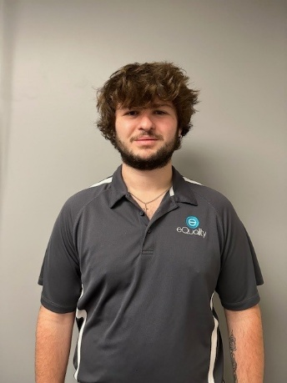
2007 Toyota Avalon | Grey

eQuality Valuation Services (203) 346-1000

For Public Press Release/Posting

Dear Sir or Madam:

This letter is to introduce Eric of eQuality Valuation Services LLC, the firm that has been hired to assist the Assessor and the Town of Plainville in the completion of the 2026 Revaluation.

Eric will be taking photographs and inspections Residential and Commercial buildings where required. Your cooperation will be greatly appreciated.

Eric’s vehicle will have eQuality Valuation Services magnets. Should you have any questions, please call the Assessor’s Office at (860) 793-0221 x7131.

Sincerely,

Bridget Boucher
Assessor

Automobile | Color | 
Dodge Journey | Black

eQuality Valuation Services (203) 346-1000

For Public Press Release/Posting

Dear Sir or Madam:

This letter is to introduce Michael of eQuality Valuation Services LLC, the firm that has been hired to assist the Assessor and the Town of Plainville in the completion of the 2026 Revaluation.

Michael will be taking photographs and doing inspections on Residential and Commercial buildings where required. Your cooperation will be greatly appreciated.

Michael’s vehicle will have eQuality Valuation Services magnets. Should you have any questions, please call the Assessor’s Office at (860) 793-0221 x7131.

Sincerely,

Bridget Boucher
Assessor

Automobile | Color | 
2016 Cadillac CTS | Black

eQuality Valuation Services (203) 346-1000

