STORMWATER INFORMATION
(January 2023)

Two major rivers flow through the borders of Plainville: Pequabuck River and Quinnipiac River. Both rivers and their associated wetlands provide habitat for wildlife and recreational opportunities for the community.

Being good stewards of these watersheds is the only way to protect the water quality of these rivers and associated wetlands. Everyone must do their part to prevent stormwater runoff from polluting these waters. Rainwater and snow melt under natural conditions may collect small amounts of impurities as they run overland or in groundwater. These small amounts of impurities are attenuated (neutralized) naturally by organisms in the soil and water. Development by man can concentrate impurities making it difficult for natural attenuation. Without natural attenuation, wetlands, rivers and streams receive waters containing impurities at concentrations which degrade the environment. The result is the water bodies we all cherish are degraded sometimes to a degree which they become a hazard.

We all need to do our part in minimizing the impurities that stormwater comes in contact with. Some people are unaware of how their actions can impact the environment. Stormwater runoff from roofs, lawn areas, driveways and other surfaces on your property discharge water directly or indirectly into streams, wetlands, ponds and even the ocean. Your actions matter.

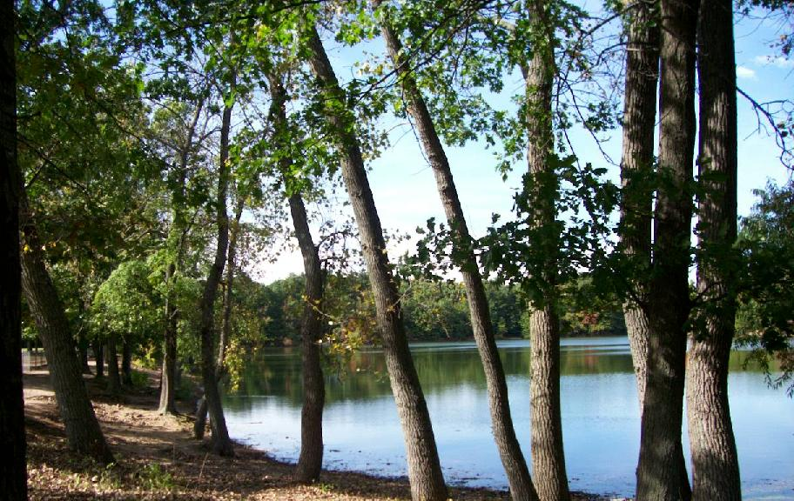

Common Practices Property Owners Should Consider

Lawn Care

Managing Leaves, Grass Clippings and Yard Trimmings

Managing leaves and yard trimmings can be challenging.

Leaves are collected curbside from late October to early December. During other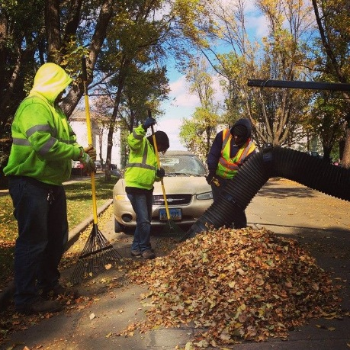 times of the year leaves can be bought to the Transfer Station, Saturdays April through December. No fee is charged.

Branches and twigs can be brought to the Transfer Station on Saturdays from April through December. A fee is charged based on the amount of branches and twigs.

The Town of Plainville does not provide any collection or disposal options for grass clippings. Property owners are advised to employ a series of tactics to manage grass clippings. The tactics begin by considering whether large lawns are necessary. Replacing lawn areas with natural plantings has the possibilities to reduce the financial resources necessary to maintain these spaces. Additionally, natural plantings require less time to maintain. In those grass areas that are deemed necessary, property owners should consider the amount of nutrients (fertilizer) needed to maintain the quality of yard area desired. Minimizing fertilizer will minimize the need to trim the grass, thus, minimizing the amount of grass clippings to manage. Trimming grass areas in ½ to ¾ inch increments will permit those grass clippings to be left in place. The grass clippings will disappear quickly as they dry and filter down to the soil surface and decompose.
Fertilizer Application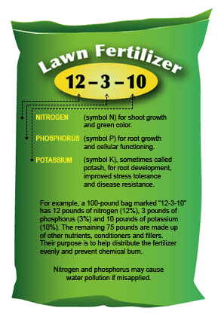

Healthy lawns, trees and shrubs add beauty and value to properties. The truth be known that Connecticut’s seasonal climate is so varied that maintaining a “perfect lawn” throughout the whole growing season would ideally need two completely different turf types, cool and warm season grasses, with two different sets of growing requirements.

Maintaining healthy lawns and landscape plants often requires the use of fertilizers. Improper use of fertilizers can cause water pollution. The quest for the perfect lawn has led to high concentrations of nitrates, phosphorus and pesticides in our waterbodies through runoff and leaching. Additionally, lawnmowers and other lawn equipment pollute the air more per hour of use than our cars.

Fertilizers contain three or more nutrients. Nitrogen and phosphorus when washed into streams, lakes and waterbodies degrade the environment because they promote unsightly algae blooms and aquatic weed growth, lower dissolved oxygen levels in water and may release ammonia which is toxic to fish.

Any fertilization program should begin with a soil test. Soil tests will provide specific fertilizer recommendations and can help avoid the over application of fertilizer. Lawn experts recommend beginning a fertilization program in the fall when the average daily temperatures are approximately 50⁰. Early spring fertilization applications have been shown to harm lawns by promoting more top (leaf) growth than root growth. Poorly developed root systems are unable to sustain the new leaf growth and are thereby vulnerable to summer drought. During the fall, grass plants preparing for winter expend more energy on the development of roots than leaf growth. Fall fertilizer formulas and applications support root development.

Two types of fertilizers are available commercially, synthetic based and organic based. Organic based fertilizers contain relatively lower concentration of plant nutrients as compared to synthetic fertilizers. Additionally, organic fertilizers release their nutrients more slowly. Many synthetic fertilizers are fast release fertilizers, however, technological advances in synthetic fertilizers have made some synthetic fertilizers slow release.

The selection to use fast or slow release fertilizer depends on your soil type which the initial soil test will determine. In heavy or clay soils fast release fertilizers are a better option. The low permeability of clay soils restricts the opportunity of the fertilizer nutrients from being washed away before the grass can use them. In sandy soils, however, slow release fertilizers are the best option because the high permeability of the soil increases the likelihood the nutrients with be leached into the groundwater before the plants can use the nutrients. Slow release nutrient sources delay and extend the period the nutrients are available to the plants.

Fertilizers are formulated with the basic nutrients: Nitrogen, the first number in the formula, followed by Phosphate and Potash. Each number in the formula represents the number of pounds of that nutrient found in one hundred (100) pounds of the fertilizer. Most lawn fertilizers are sold in volumes to be applied to a certain amount of area and provide a bag weight. Users should heed the recommended rates specified on the bag yet keep in mind the following recommended application rate and apply the least amount. Listed below is the recommended amount of Nitrogen to be applied for 1000 square feet, a square approximately 32’ by 32’.

Pounds of nitrogen per 1000 sf of lawn area

Time of Application Grass Clippings Removed Grass Clippings Not
Removed
October 1 | 1.25 LB | 1.00 LB
Late May | 1.25 LB | 1.00 LB
Late June | 0.75 LB | 0.50 LB
Late August (optional) | 0.75 LB | 0.50 LB

Fertilizers inadvertently spilled on non-grass surfaces need to be swept up immediately before they are washed into the stormwater system or waterbody.

Pesticide Application

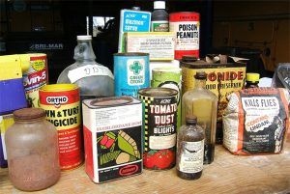
Pesticides are toxic chemicals which include herbicides, (which kill plants), insecticides (which kill insects), and fungicide (which kill fungi). These chemicals pose a threat to animals, plants and insects beyond the intended pests. Natural biological pest control organisms often succumb to pesticides. These organisms include honeybees, ladybugs and fish.

When some see weeds or insects invading their plants, their first response is often to apply a pesticide. Some people even apply a pesticide to prevent invasions by pests. Both responses lead to unnecessary pesticide use. A more ecological response is Integrated Pest Management (IPM). IPM is an ecological approach to pest management that integrates cultural, mechanical, biological and as a last resort chemical control methods.

The basic concepts of IPM are as follows:

Informational Approaches
Learn about plants and their pests;
Select the right plants for the location;
Frequently inspect the plants to evaluate whether the pest levels are increasing or decreasing;
Identify pest symptoms, knowledge of pests, their life cycle and their likely damage;
Determine if control measures are necessary, most plants can tolerate considerable damage;
When treatment becomes necessary select methods that are least disruptive to natural controls; and
Evaluate your treatment to determine effectiveness.

Cultural Controls
Cultural pest control methods attempt to create optimal growing conditions for the plants and unfavorable condition for the pests.
Plant varieties that are disease resistant and adapted to the local conditions;
Plant a variety of plants to reduce potential total failure;
Plant plants in proper locations as required for sunlight and water;
Maintain rich, fertile soil with proper pH;
Rotate plants to disrupt life cycle of pests;
Plant and harvest early before pest populations peak;
Remove pest infected plants; and
Maintain plants for optimal growth.
Biological Controls
Numerous organisms feed upon or infect insect pests. Create an environment that supports biological diversity. Minimizing chemical pesticides allows natural enemies to survive/thrive to keep pest populations in check.

Predators – Such as ladybugs, ground beetles, other insects, birds and bats consume many pests during the growing season.

Parasites – such as the trichogamma wasp affect a targeted pest reducing that pest to manageable levels.

Pathogen – such as fungi, bacteria and viruses which infect insect pests.

Mechanical Controls
Utilize mulches to reduce weeds, conserve moisture and enrich soils;
Hand pick insect pests if practical;
Till soil in weedy areas rather than using herbicides; and
Hand weed.

Chemical Controls
After accurately identifying the pest, determining the plant’s survival threshold will be exceeded, and assessing other controls have or will not work, select the appropriate chemical pesticide. Pesticides are most effective during certain stages of the pest’s life cycle and at specific concentrations. If possible, select a pesticide that is designed to kill only a select group of insects, weeds or organisms. Consider the least toxic options first: Microbial Insecticides such as Bacillus Thuringiensis or Insecticides Soap or Oils. Insecticides Soaps and Oils destroy pest membranes on contact and are effective on soft-bodied insects.

Pesticide Application Considerations
Read the label carefully and follow the directions provided;
Prepare and apply the amount specified in the directions;
Wear protective clothing and wash clothing separately;
Do not mix different types of pesticides;
Keep pesticides in their original containers and store in accordance with directions;
Do Not apply pesticides if rain is forecasted unless specified in directions; and
Never apply pesticides to bare ground or eroded areas.

Watering

American cities and suburbs have grown and spread throughout the countryside creating an unprecedented amount of manicured lawn areas. Keeping these lawns emerald green, barefoot soft and dandelion free requires a significant amount of water and attention.

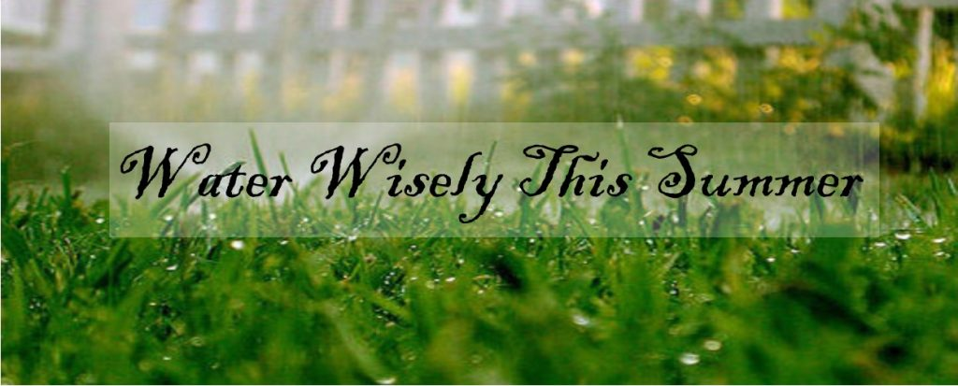

Careless watering practices can have a serious impact on lakes, streams and groundwater. The careless watering practices of one property might not seem like a big problem but imagine the cumulative impacts of hundreds of properties. Poor lawn watering practices can wash pollutants into waterbodies, deplete water supplies and damage the lawn. Water running off your yard can erode soil, waterlog sensitive plants and or wash away fertilizer or other lawn chemicals. Minimizing careless practices will result in healthier lawns and cleaner water.

Most of Connecticut’s lawns are composed of cool weather grasses. Cool weather grasses are generally green from early Fall to midsummer. Without a proper amount of water cool weather grasses go dormant (brown) during the July and August. Cool weather grasses require about one inch of water per week to avoid summer dormancy.

Warm weather grasses are considered generally undesirable turf grasses because they remain dormant, (brown), during the cold and cool months of the year. Warm weather grasses are dormant until late spring and return to dormancy in early fall. Warm weather grasses grown in Connecticut do not generally require summer supplemental watering. Natural precipitation is adequate to maintain a green colored turf surface.

One should consider how important a green lawn is. During the spring, early summer and fall, natural precipitation is plentiful enough to keep most cool weather grass varieties green and vibrant. Warm weather grasses are dormant more months than they are green due to Connecticut’s climatic conditions.

If you choose like most Connecticut residents cool weather grasses, no amount of midsummer watering will allow cool season grasses to look as good as they do in spring or fall. A dry lawn has a blue-green color but does not spring back when you walk on it. Dormant cool season grasses will be a brownish green color. Differentiating between a dry or dormant lawn will determine how effective water will be to reestablish a green lawn by watering. Dormant grasses will require larger volumes of water along with cooler weather conditions to regain their lush green color and texture. Prolonged high summer temperatures will inhibit the return of a green lawn no matter how much water is applied. Studies have demonstrated that lawns that were watered throughout the summer generally look no better in September than lawns that were not watered. Property owners can be confident that not watering their lawn in the midsummer months will not harm their lawns.

Actions to Consider

Let Grass Grow Taller
Taller grass promotes deep rooting
Mow no shorter than two inches
Taller grass shades the soil surface thus reducing evaporation and discourages sprouting weed seeds

Use Chemicals Wisely
Proper fertilizing promotes deep roots
Don’t fertilize a dry lawn – high concentration of nutrients tends to draw moisture out of grass
Control weeds to reduce competition for soil moisture

Consider Weather
Don’t cut grass during the heat of the day – newly cut blades lose water quickly
Don’t water if one-inch storm has occurred in the last week or is forecasted in the next few days

Other Factors
Consider landscaping that requires less moisture
Many consider a diverse landscape more aesthetically pleasing – while providing enhancements for pollinators and other wildlife
Consider bluegrass and fescue mixes which are more drought tolerant than rye grasses
Direct downspouts to planting beds or lawn area
Consider temporary brown-out – a few weeks of summer dormancy will not harm a healthy lawn

Art of Fine Lawn Watering
Apply water at a rate of one inch per week all at once
Water early in the Morning
Mulch newly seeded area – reduces evaporation
Newly seeded areas - Lightly water daily to keep soil evenly moist
As newly seeded areas grow, decrease the number of watering from daily to once per week at two inches of growth
Consider a timed sprinkler – automatically shuts off after desired rate
Use a sprinkling can or hand-held hose to target small areas
Aerate your lawn yearly
Adjust sprinkler to eliminate overspray on non-lawn areas

http://www.ct.gov/deep/cwp/view.asp?a=2708&q=382644
https://www.popularmechanics.com/home/lawn-garden/how-to/g541/organic-lawn-care-tips-47071704/
http://www.ct.gov/deep/cwp/view.asp?a=2708&q=323952&deepNav_GID=1763

https://www.thermostat-recycle.org/statelaws/connecticut
Proper Disposal Practices for Common Household Substances

Hazardous Waste
The product container shall have the following warning words to alert you to the hazardous nature of the product:
Poison, toxic, corrosive, volatile, flammable, inflammable, combustible, explosive, danger, caution, warning, and harmful.

Product descriptions containing these warning words require special disposal practices and should be disposed of at Hazardous Waste Collection Locations and Dates.

The Connecticut Department of Energy and Environmental Protection has developed an extensive list of products and the appropriate method of disposal at the web link noted below.
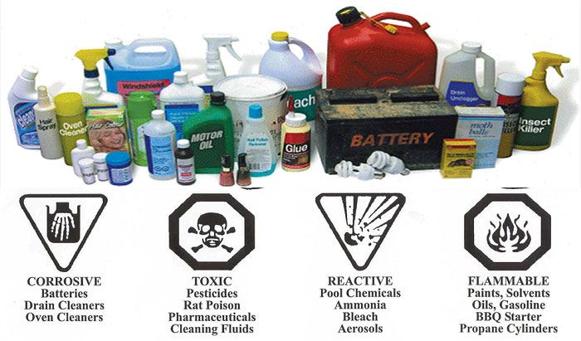

http://www.ct.gov/deep/cwp/view.asp?a=2718&q=325496
https://www.plainvillect.com/public-works/pages/hazardous-waste-collections
http://www.ct.gov/deep/cwp/view.asp?a=2708&q=323956&deepNav_GID=1763

Mercury Disposal

Mercury is a silver colored liquid metal that had and has many industrial, commercial and residential uses. Common items that may contain mercury include thermometers, thermostats, gauges, fluorescent toys and games, and electric switches and relays.

Mercury is toxic and becomes dangerous when it comes in contact with air and vaporizes. Stormwater can wash mercury which is improperly disposed of. In waterbodies, bacteria converts the mercury into methylmercury which is harmful to all living organisms.

You can’t see, smell or taste mercury or methylmercury. Exposure to mercury or methylmercury has serious short and long-term consequences. Exposure to short-term high levels are known to cause headaches, lung damage, nausea, vomiting, skin rashes, diarrhea, increases in blood pressure and heart rate. Long-term exposure can lead to permanent damage to the brain, kidneys and developing fetus. Children under the age of six (6) and women who are pregnant or planning to get pregnant are most at risk to the health effects of mercury exposure. Equally as important are the health risks associated with cumulative exposure to mercury and or methylmercury.

Use caution when handling mercury or items likely to contain mercury. Never break open items that contain mercury or are likely to contain mercury. Never burn mercury containing products. Do not pour/flush mercury down the drain. Do not put mercury containing items in the trash. Always properly recycle mercury containing products at a household hazardous waste collection.

Mercury thermostat collection legislation was passed in Connecticut requiring thermostat manufacturers to establish collection programs for contractor and consumer -generated mercury thermostats. The legislation also requires all HVAC wholesale distributors with facilities in Connecticut to act as a collection point for waste mercury thermostats. To locate a collection point, please use the search tool below.

https://www.thermostat-recycle.org/statelaws/connecticut

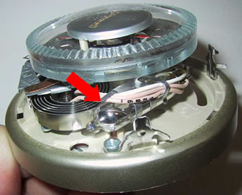

Pet Waste Management

Pet Owners, when you clean up after your pet, do you dump the waste in the street or storm sewer? Do you leave it to decay on the sidewalk or the grass near the street? If so, you may be causing pollution and or health issues.

Picking up after your pet isn’t just a courtesy for those walking behind you: it is the healthy and environmentally sound thing to do. When pet waste is not properly disposed it can be carried by rain or snow runoff into nearby waterbodies or storm drains. Untreated animal waste can become a source of harmful bacteria and nutrients in surface water. Just as we don’t want human waste in our water it is important to prevent pet waste from being carried into our waterways because of negligence. Always pick up your pet’s waste. It is not a fertilizer. Carry Disposable Bags, Bag it and Toss it in a Proper Receptacle

Stormwater samples collected in Plainville almost always have high bacteria levels which violate water quality standards. A likely contributor is improperly managed pet waste.
Dog waste is an environmental pollutant and is labeled a non-source pollutant placing it in the same category as herbicides, insecticides, oil, grease and other toxic chemicals. Dog waste contains millions of fecal coliform bacteria. The United States Environmental Protection Agency estimates that two day’s worth of droppings from approximately 100 dogs would contribute enough bacteria to temporarily close an ocean bay or lake within twenty miles to swimming. Pet waste left on lawns, curbs, sidewalks and streets wash into local waterways either directly or through the storm drainage system during rainstorms. The decay of pet waste also creates nutrients when washed into waterways. These nutrients promote algae growth which in turn can cause asphyxiation of aquatic organisms. Overly fertile water becomes cloudy and green making it unattractive for swimming, boating and fishing. However, most importantly, pet waste carries diseases which make water unsafe for swimming or consumption.

Pet waste should always be picked-up in a timely manner to prevent it from impacting the environment. Expert Sources agree that collecting and throwing the waste into the trash that will be incinerated is the best disposal option.

http://www.ct.gov/deep/cwp/view.asp?a=2708&q=457360
https://www.mass.gov/guides/education-in-nonpoint-source-pollution-prevention
Swimming Pool Discharge

Swimming pool filter backwash, chlorinated or salt laden pool water may not be discharged to a storm sewer or a waterway per Federal, State and Town regulations. Filter backwash, chlorinated pool water, and saltwater discharge during swimming pool operation and maintenance activities contain pollutants such as dissolved solids, suspended solids, chlorides and abnormal ph. Backwash water may also contain pathogenic micro-organisms. It is illegal to discharge filter backwash, chlorinated pool water or saltwater from saline pools into the Town’s drainage system or Town street. Fines and or penalties may result if a property owner inappropriately discharges pool water or backwash.

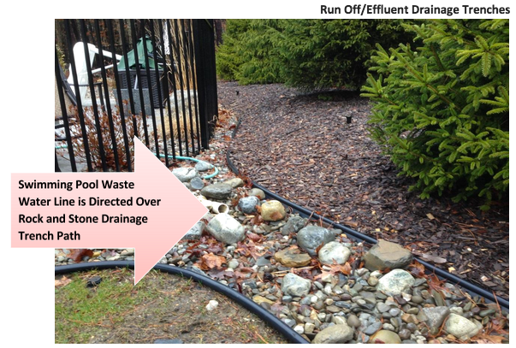

Pool water needs to be neutralized of chlorine or salt before being discharge to a vegetated surface. The vegetated surface needs to be of a proper size to infiltrate all the water into the ground before it reaches the nearest imperious surface or waterbody.

Outdoor swimming pools and their water are typically discharged only once a year after the swim season. Addressing the presence of chlorine and disinfection salts is a concern. Chlorination must be stopped in advance of any discharge. Allowing the water to age without chlorination enables the chlorine to dissipate. Prior to discharging the water, the water should be tested using a standard chlorine pool test kit. The level of chlorine should be 0.0mg/l and pH of between 6 and 9 standard units. In most instances three or four days are sufficient to eliminate all the chlorine. Should the pH be outside the acceptable range, the water’s pH should be adjusted prior to discharge. If the pool’s disinfection system utilizes salts, the pool water needs to be neutralized in accordance with the disinfection system’s manufacturer’s recommendation. Saline water can significantly impact vegetation and soils due to the high salt content.

The pool discharge should be directed onto a vegetated surface to encourage infiltration. The vegetated area needs to be large enough to contain the discharge without any subsequent runoff or negatively affecting neighboring properties. Care should be taken not to create puddles of standing water which could potentially provide breeding grounds for mosquitoes. Under no circumstances should the discharge be directed onto an impervious surface such as a roadway, sidewalk or driveway. Additionally, no discharge should be directed into a waterbody.

Pool filter backwash water should be discharged to a vegetated surface where it can infiltrate into the ground. Diatomaceous earth filters should have a system designed and constructed for setting out waste DE so that it can be removed as needed and disposed of in the trash. Caution should be used when backwashing diatomaceous earth filter material as it will harden to a cement like consistency over time damaging soil and vegetation.

https://www.swimuniversity.com/how-to-reuse-your-filter-backwash-water/https://www.mass.gov/files/documents/2017/09/29/swimming%20pools.pdf

Automobile Maintenance and Cleaning

As we drive, our cars and trucks leave bits of tires, brakes, metals and other materials on the street. When we park, our cars and trucks, they leave stains of oil, grease, transmission and other fluids on driveways and parking areas. Less visible are the tiny exhaust particles that gradually settle out of the air or come down with the rain and snow. When it rains or snows, all these materials are washed into water bodies. We can reduce or stop/minimize this kind of pollution if we consider the following practices:
Recycle Used Oil;
Use Commercial Car Washes;
Keep Your Car in Sound Mechanical Order;
Repair Leaks;
Recycle Antifreeze;
Return Used Batteries;
Check your Tire Pressure;
Dispose of Vehicle Fluids Properly;
Substitute Shoveling for Salt; and
Drive Less.

Residents changing their oil and or performing other maintenance on their vehicle should refrain from disposing any waste products on the ground or empty containers into the catch basins.

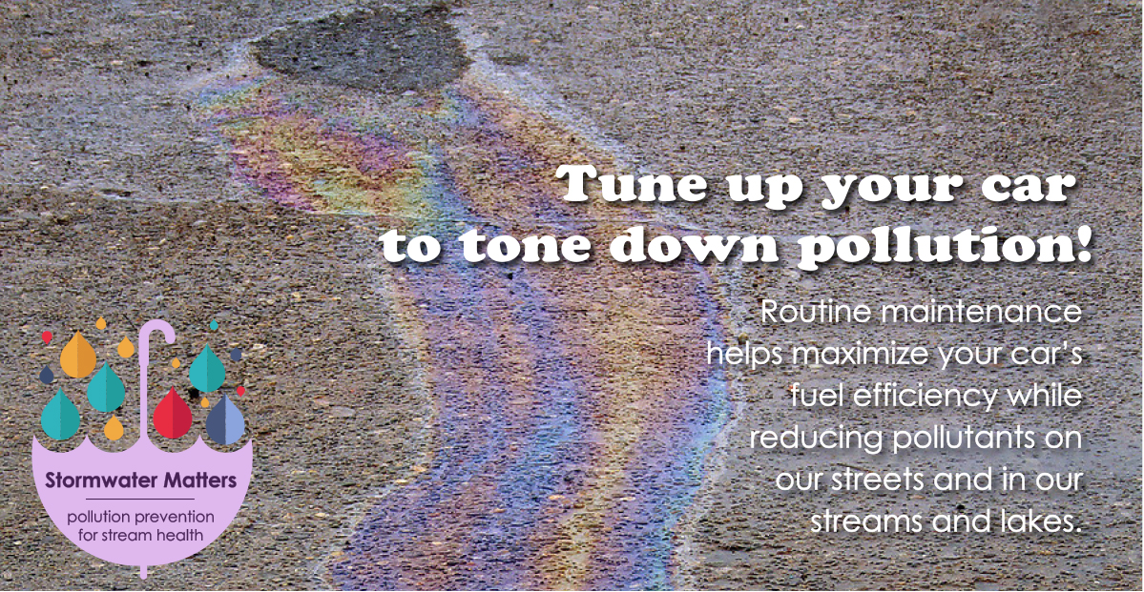

Used oil and other waste fluids and materials cause water pollution when they encounter rainwater or snow melt. Used oil can be taken to many auto parts stores or brought to the Town’s Transfer Station on Granger Lane. Other vehicle fluids (Transmission fluid, power steering fluid, hydraulic fluid, brake fluid, antifreeze fluid, windshield fluid and fuels), should be collected and disposed of at a Hazardous Waste Collection site. Each type of vehicle fluid should be kept in a separate container. The dates and locations for scheduled hazardous waste collections can be found on the Town’s Transfer Station web page.

Just one quart of improperly disposed of vehicle fluid can contaminate millions of gallons of water. Violators are likely to be subject to penalties, fines and possibly responsible for the costs of any clean-up.

Also it is best to wash your vehicle at a commercial car wash. Commercial car washes have been designed to collect and properly dispose of soap products and other contaminates which may be rinsed off your vehicles. The waste water is ultimately directed to a wastewater treatment plant. Should you choose not to use a commercial car wash, you should wash your vehicle in an area where the rinse water will percolate into the ground to prevent it from flowing directly into a water body. Percolation into the ground will provide an opportunity for the soil to naturally attenuate some or all the impurities found in the rinse water before it comes in contact with a water body.

http://cwsec-sc.org/where-should-i-wash-my-car/
https://www.plainvillect.com/public-works/pages/hazardous-waste-collectionshttp://www.ct.gov/deep/lib/deep/waste_management_and_disposal/used_oil/ManagementDIYUsedOil.pdf

Winter Maintenance and De-Icing
Snow and ice on roads, parking lots, driveways and sidewalks can create safety hazards for those using them. Yet many conventional practices utilized to minimize or eliminate the safety hazards cause environmental damage. The application of de-icing chemicals, chloride salts primarily, often applied in excess amounts cause plants and organisms to die as the result of dehydration. Additionally, chloride salts contaminate drinking water sources impacting human health. Sand and other abrasive material cause greater environmental harm than salts.
The method which impacts the environment the least involves mechanical scraping using plows and shovels. The results of mechanical scraping alone are admittedly not usually adequate to ensure safety, thus, deicing materials need to be used. Chemical ice melters, sometimes mixed with sand are applied to surfaces to make them safe. Sound environmental practices for winter maintenance and the use of chemical deicers involve using the least amount of material to break the bond between the surface and ice/snow such that mechanical methods can be employed to create safe conditions.
Salts work by lowering the freezing point of water. The results are the conversion of solid ice and snow into a liquid water or at the very least the breaking of the bond between the surface and the ice or snow allowing it to be scraped away. The more surface area which comes in contact with the salt or brine the more snow/ice that melts. The brine flows/spreads onto and around more ice/snow creating more liquid brine. This process will continue until the salt concentration of the brine is reduced to the point where the temperature of the surrounding area is lower than the melting point of the liquid brine.
Deicers contain harmful salts when dissolved in snow melt exceed the toxic levels for many organisms. Even in small quantities salt can: dehydrate an organism, deplete the oxygen supply needed by aquatic animals and plants, leach into the ground and change soil composition making it difficult for plants to survive, contaminate groundwater and surface water and deteriorate paved surfaces, buildings, and infrastructures. Studies indicate in urban/suburban areas with impervious surface densities of greater than twelve (12%) percent have toxic salt concentrations which persist in surface waters for between 100 to 200 days per year. The only organisms which survive are the ones most tolerant to the toxic effects of the salts. Overall biodiversity is greatly diminished.
Dissolve salts are difficult to remove from the environment. For all practical purposes, they remain in the water forever. Conventional environmental mitigation practices designed to settle, or filter contaminates do not capture the salts. These practices simply transfer the salts from surface water to groundwater. The methods to remove dissolved salts are distillation, vacuum distillation and reverse osmosis. These methods are the ones used to desalinate ocean water into drinking water
The only way to minimize the impacts of deicing salts on the environment is to reduce the amount of salt you apply to the bare minimum needed to accomplish the goal. If you commonly have salt left on the dry surface after the snow/ice is gone, it is time to reconsider your application rate and strategies.
The best approach to maximizing the efficiency of a deicing application is to recognize that less is needed when temperatures are/expected to be close to 32° F and as the temperature drops to 15° F more is needed. Below 15° F chloride salt is ineffective, and the application of abrasive materials need to be considered. The use of dry salt should be avoided. The application of dry products creates more scatter/bounce and uneven distribution, thereby resulting in the application of more material over a wider area. Studies have shown up to 30% more material is applied to achieve the same result. Additionally, the study determined this excess material treated areas outside the intended zone.
A more environmentally friendly deicing method involves applying a brine solution prior to the storm event and prewetted solid materials during and after the storm event if necessary. Both applications minimize the scatter/bounce effects of applying material.
A salt/water brine can be sprayed more evenly and penetrates into irregular surfaces. Liquid brine consisting of 23% salt, 2.5 lbs. per gallon, applied in narrow bands as an anti-icing agent is effective as it prevents the formation of bonded snow and ice to the surface. The application rate should be .5 gallons to .75 gallons per 1000 square feet. The application creates a layer of brine slush that separates the surface from ice/snow which can be more easily mechanically scraped away. The application of salt brine in narrow bands creates improved traction when the slush layer is created. An anti-icing application should be avoided when the expected temperature will be lower than 20° F, when strong winds are expected, during heavy snow events, or freezing rain conditions. In windy conditions, anti-icing can actually cause blowing snow to adhere to the surface, heavy snow can dilute the brine salt concentration so the freezing point is not lowered enough to prevent refreezing and rainy conditions will wash the liquid chemical away. Salt brine should not be applied if the surface is covered by ice or snow. The concentration of salt brine will quick be diluted making the application ineffective.
After mechanical scraping has been performed prewetted, solid material can be applied to dislodge any snow or ice which has adhered to the surface. Prewetting the solid material improves the adhesion of the salt to the surface and accelerates the process of melting the snow and ice. Prewetting the salt kick starts/preactiviates the melting process. The salt brine/snow melt is more effective at melting ice and snow than solid material.
The appropriate amount of applied salt is temperature dependent. The closer the surface temperature is to 32° F the less salt needed to melt snow/ice. Additionally, less prewetted salt is needed verse dry salt. More salt doesn’t necessarily yield quicker or increased melt.

Suggested Deicer Application Rates Range for Driveways, Parking Lots and Sidewalks per 1000 square feet of area
Ambient Temperature | Application Rate
30° F or Greater | 4.5 lbs. to 7lbs.
25° F to 30° F | 5.75 lbs. to 8.25 lbs.
20° F to 25° F | 7 lbs. to 10 lbs.
15° F to 20° F | 7.5 lbs. to 10lbs
Below 15° F | No Salt Application – Apply Abrasives

A one-pound coffee can will hold approximately 2.5 pounds of Deicer
Within the application range, lower amounts should be considered when the temperature is expected to rise and prewetted salt is used. Higher application rates should be considered when applying dry salt and/or the temperatures are expected to drop.

Below 15° F deicer salts are ineffective and do not melt the ice or snow under these circumstances . Abrasive materials should be used until temperatures rise above 15° F at which time a judgement needs to be made whether a lesser amount of salt corresponding to additional melting time addresses the need or a higher amount of salt and less melting time is appropriate.

